Lock Monitoring

Scripts: prepare.sql, test.sql, test1.sql, lock_monitoring.sql

deadlock with “for update” situation

test.sql  
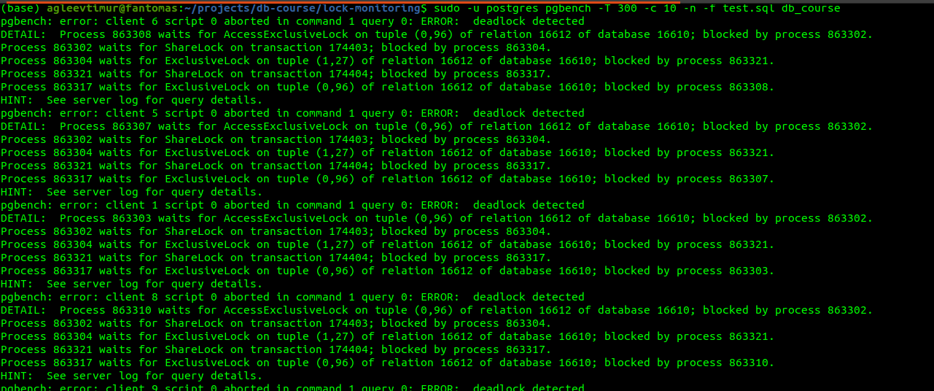  
  
test2.sql  
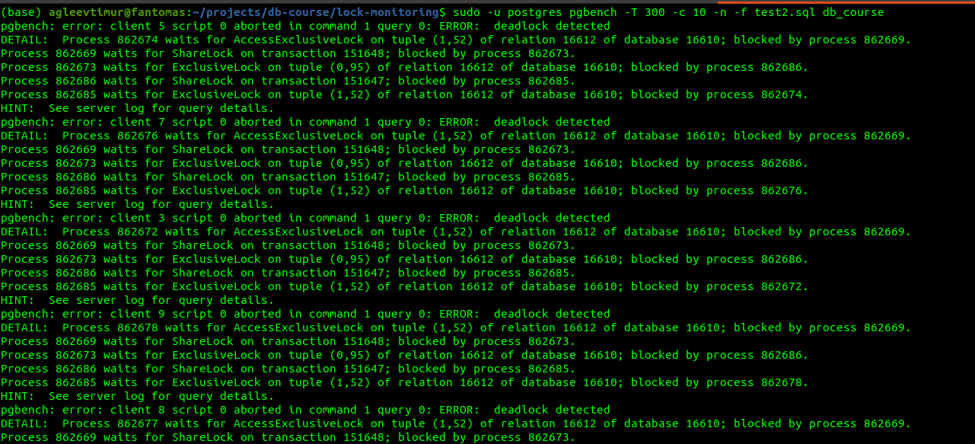

Result of lock monitoring(lock_monitroing.sql):  
